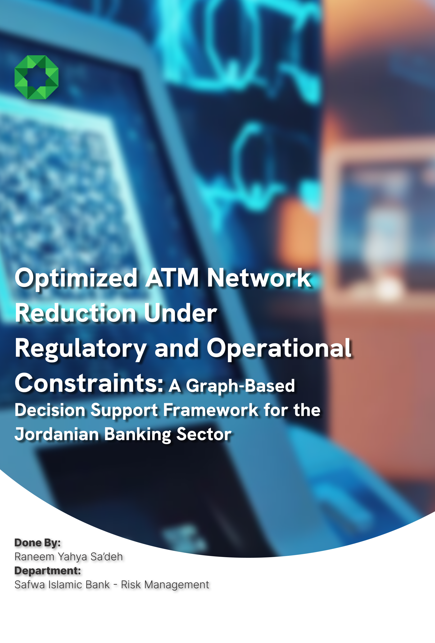

Problem Definition
I’m facing a network optimization under constraint problem. The Central Bank may force a 25–50% reduction in operational ATMs. My job is to decide which ATMs to keep running so that:
- Service coverage is maximized (geographic, temporal, transactional)
- Financial loss is minimized
- Risk scenarios are handled (curfew/mall closures, fuel/power shortages)
I have 45 ATMs across Jordan (Amman, Zarqa, Irbid, Mafraq, Karak, Salt, Ramtha, Jerash, Madaba, Aqaba). If I keep 50%, I keep ~22–23 ATMs. If 25%, only ~11.

The Data to Collect
Per ATM (from your document + enrichment):
Feature | Source | Notes
Location (lat/lng) | Google Maps geocoding | Critical for spatial graph
Branch type | Your doc | Mall vs. street branch
Operating hours | Your doc | Mall branches are open later
Services offered | Your doc | NFC, cash deposit, contactless withdrawal
Transaction volume (daily/weekly) | Core banking | Most important signal
Unique customer count | Core banking | How many people depend on this ATM
Avg. transaction value | Core banking | Revenue proxy
Power source type | Operations dept. | Grid-dependent vs. generator
Fuel/generator backup hours | Operations dept. | Critical for outage scenario
Nearby ATM distance | Computed | Substitutability if this ATM closes
Population density in 500m radius | GIS/Census | Demand proxy
Nearest alternative ATM (same bank) | Computed | Graph edge weight

Solution Architecture
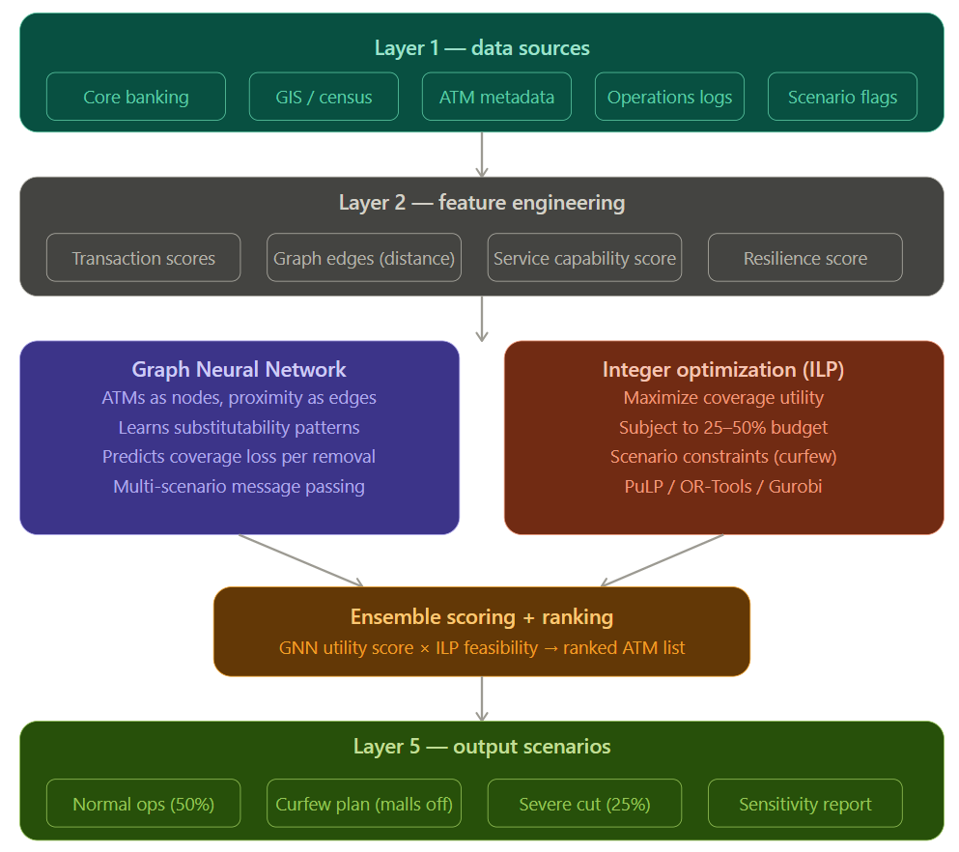

ATM network graph is structured
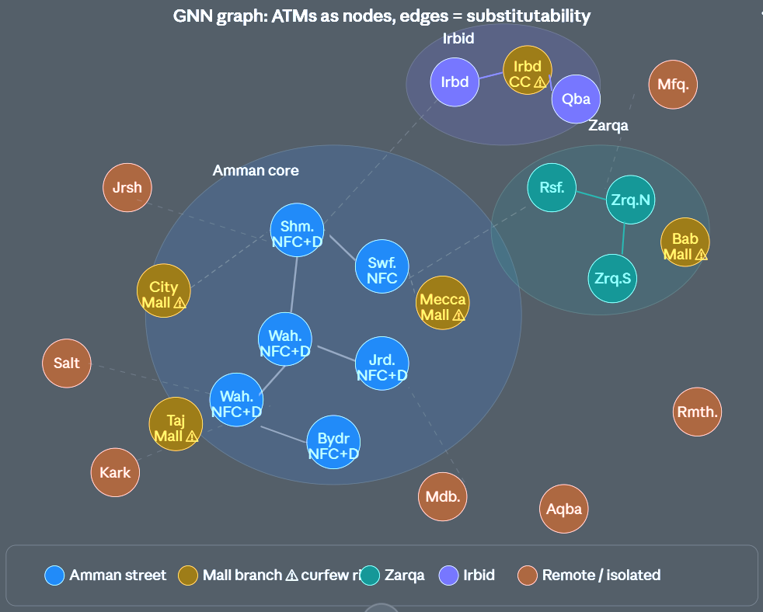

The Three-Model Approach in Detail

Model 1 — Graph Neural Network (GNN)
Why GNN: ATMs don't exist in isolation. If you remove ATM A, its customers don't disappear — they migrate to the nearest substitute. GNNs model this network dependency natively.
Setup: Build a graph where each ATM is a node with features (transaction volume, services, hours, location, power resilience). Edges connect ATMs within a configurable radius (say 2 km), weighted by inverse distance. You then use a GraphSAGE or Graph Attention Network (GAT) to learn a utility embedding for each node — essentially: "how much network value does this ATM carry?"
The key task you'd train on is coverage loss prediction: given a subset of removed ATMs, predict the number of customers left unserved. With historical data on branch closures (maintenance, outages), you can generate training examples.

Model 2 — Integer Linear Programming (ILP)
Why ILP: Once the GNN gives you a utility score per ATM per scenario, the selection problem is a classic budgeted maximum coverage problem — provably solvable with ILP.
The formulation:
Maximize: Σ (utility_i × x_i)
Subject to: Σ x_i ≤ k (where k = 25% or 50% of 45)
And: x_i ∈ {0,1} (keep or remove)
Scenario constraints: if curfew → x_mall_i = 0 forced
Power constraint: at least 1 generator-backed ATM per region

Model 3 — Scenario Sensitivity Analysis
Run both models across four scenarios:
Scenario | Constraint | ATMs to keep
Normal 50% reduction | Power/fuel cost | ~22 ATMs
Curfew (mall closures) | 7 malls forced off + 50% budget | ~22 from remaining 38
Severe 25% + curfew | Both constraints active | ~11 ATMs, all street branches
Rolling outage | Generator backup ≥ 4hrs required | Subset with backup power

From Your ATM List: Immediate Observations
Based only on the document you shared, before any model runs, here are the risk signals:
High risk of forced closure (mall branches — curfew scenario): City Mall, Mecca Mall, Taj Mall, Jerusalem St. (B5 Mall), Irbid City Centre, Istiklal Mall, Bab Al-Madina Market (Zarqa).
Highest service capability (NFC + cash deposit + contactless withdrawal — keep these): Shmeisani, Wihdat, Jabal Hussein, Sahab, Zarqa New, Ramtha, Karak, Aqaba, Salt, Dabouk, Mafraq.
Isolated nodes (no nearby substitute if removed — protect these): Mafraq, Karak, Jerash, Aqaba, Ramtha, Salt. These serve populations with no alternative. Even in a 25% scenario, removing them creates geographic dead zones that a central bank regulator would flag.
Branches with no NFC, no deposit services: Khalda, Jabal Amman, Jerash — these are candidates for removal in a severe cut if transaction volumes are low.

Recommended Tech Stack
python
# Graph construction
networkx + torch_geometric (PyG) # for GNN
# Optimization
pulp or ortools # for ILP
# Spatial analysis
geopandas + shapely # for coverage radius computation
# Visualization of results
folium or kepler.gl # for interactive ATM map output
# Scenario runner
pandas + scikit-learn # for scoring

